

**Department of Computer Science and Engineering**

| **Course Code: CSE461** | **Credits: 1.5** |
| --- | --- |
| **Course Name: Introduction to Robotics Lab** | **Semester: Summer 23** |

**Lab 2**

**Measuring distance using ultrasonic sensor**

**Prepared By,**

Shihab Muhtasim(21301610)

**Group(2) members**

Shihab Muhtasim(21301610)

Tasnia Jannat Ayesha(21301611)

Hasin Arman Prokriti(20201092)

A.B.M. Fahim Hasan Tanzin(21101257)

Tushar Chowdhury(21301010)

**Supervising faculties**

Shakir Rouf

Niloy Irtisam

**Description:**

In this experiment, we learn to measure distances precisely by combining an ultrasonic sensor with a Raspberry Pi. Our goal is to understand the fundamentals of ultrasonic sensors, how to use a Raspberry Pi, and create Python programs for accurate distance measurement. This hands-on experience empowers us to apply theory to practice, enabling us to measure distances with confidence. Through this practical exploration, we gain a solid grasp of these core concepts, paving the way for further exploration in the world of electronics and programming.

**Component requirement:**

To conduct this experiment, the following components are necessary:

● Raspberry Pi 4

● Ultrasonic Sensor (HC-SR04)

● Breadboard

● Five 220-ohm resistor

● Connecting wires (Female to Female, Female to Male & Male to Male)

● MicroSD Card

● Jumper Wires

● USB Cable

● Monitor, Keyboard, and Mouse

**Circuit Diagram:**

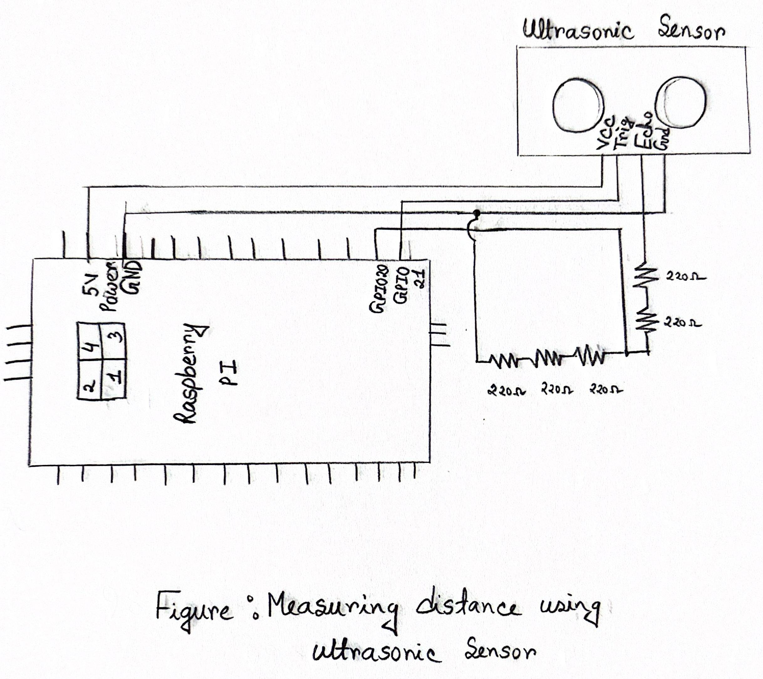

**Circuit explanation:**

We placed the ultrasonic sensor in the breadboard. The Vcc pin of the sensor was connected to the 5 V Power (Pin 4) of the raspberry pi, and the Gnd pin of the sensor was connected to the Ground pin (Pin 6) of the raspberry pi. The Trig pin of the sensor was also connected directly to the GPI021 (Pin 40) pin on the Raspberry Pi. We maintained a 2:3 ratio while connecting the resistors meaning that on one side there was two 220 ohm resistors in series and on the other side there was three 220 ohm resistors in series which ended its last end at ground. The 2 series resistor is connected with the echo as well as the GPIO 20 pin. Moreover, the 3 series resistors are connected to the GPIO20 and Ground. Hence, the GPI020 (Pin 38) pin of the Pi was connected to the node where the two resistors were connected, thus concluding our circuit.

**Circuit setup:**

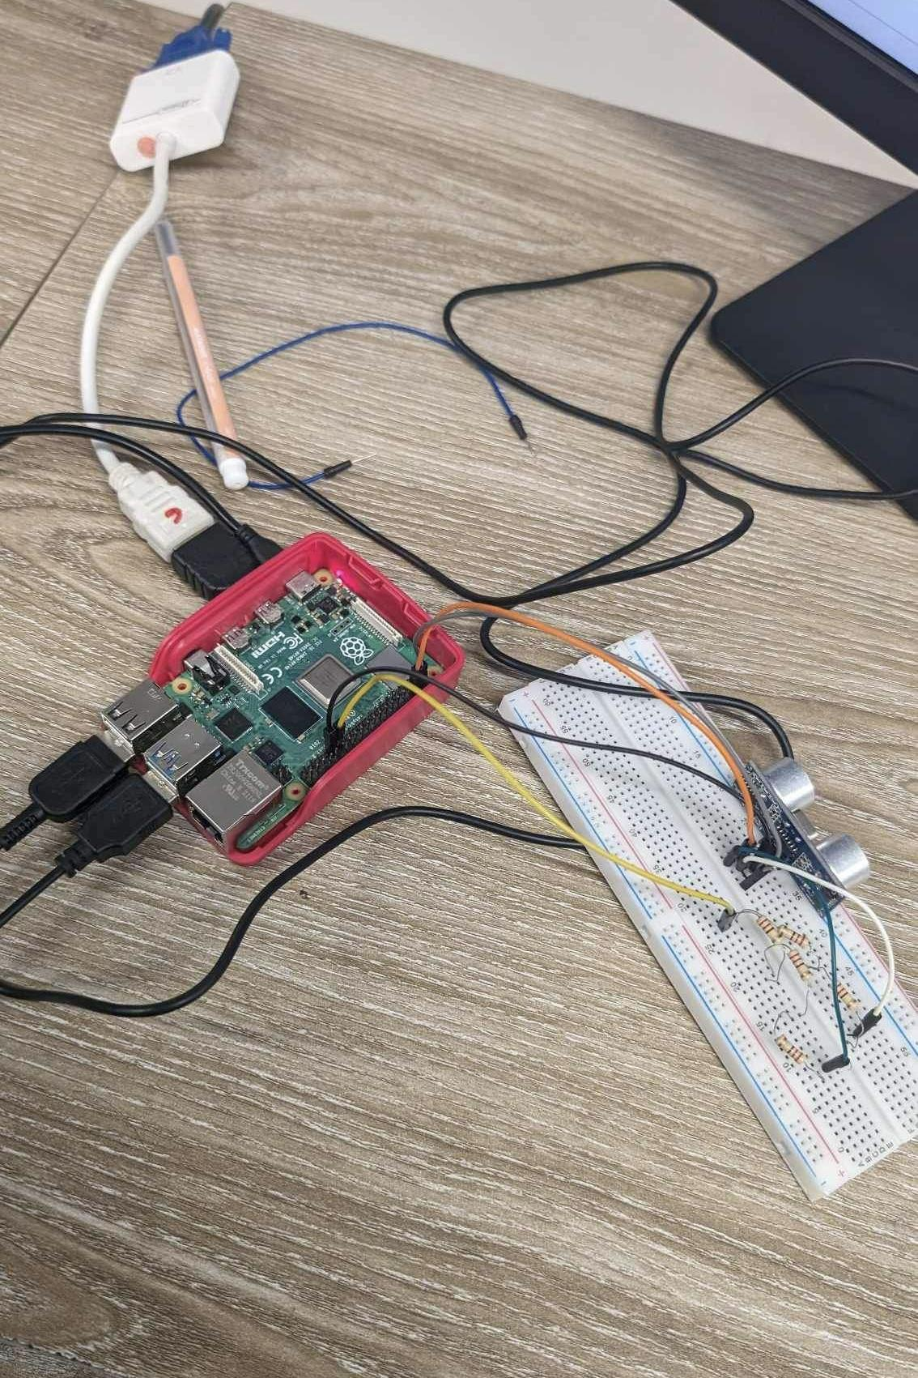

**Task: Measuring the distance using ultrasonic sensor**

**Code:**

**import RPi.GPIO as GPIO**

**import time**

**GPIO.setmode(GPIO.BCM)**

**TRIG = 21**

**ECHO = 20**

**GPIO.setup(TRIG,GPIO.OUT)**

**GPIO.setup(ECHO,GPIO.IN)**

**def distance():**

**GPIO.output(TRIG, False)**

**time.sleep(0.5)**

**GPIO.output(TRIG, True)**

**time.sleep(0.00001)**

**GPIO.output(TRIG, False)**

**pulse_start = time.time()**

**while GPIO.input(ECHO)==0:**

**pulse_start = time.time()**

**while GPIO.input(ECHO)==1:**

**pulse_end = time.time()**

**pulse_duration = pulse_end - pulse_start**

**distance = pulse_duration * 17150**

**distance = round(distance, 2)**

**return distance**

**While True:**

**print(distance())**

**GPIO.cleanup()**

**Explanation:** In this code, firstly there were GPIO library imported which helps to trigger the GPIO pins of pi. Then we set two variables to initialize the GPIO 20 and 21 pins to connect to the Trig and Echo pin of the sensor. Next we set the trig pin GPIO 20 as output from POV of pi as this pin from the sensor basically initializes the emitting of the waves from the sensor. Then the echo pin captures the returned waves which is why it's an input pin for the pi. Inside the function , after initializing the start time and the pi output trig is set, when there is no signal received the echo pin is set at 0, it is at that time when the pi start to calculate the start time of sending the pulse. Then it keeps checking for the time when echo pin becomes 1 and it is then when the signal is received and the pi calculates the end time. Then the difference between these times is multiplied by the velocity of this signal. However, its important to notice that the whole value calculated in this method is for the single to reach the object and come back. Because we only need the distance, we can consider only one way by dividing the value obtained by 2. So, at last it returns the distance. Then inside a while loop the function is continuously called to continuously print the distance between any object and the sensor that it is reflecting back from.

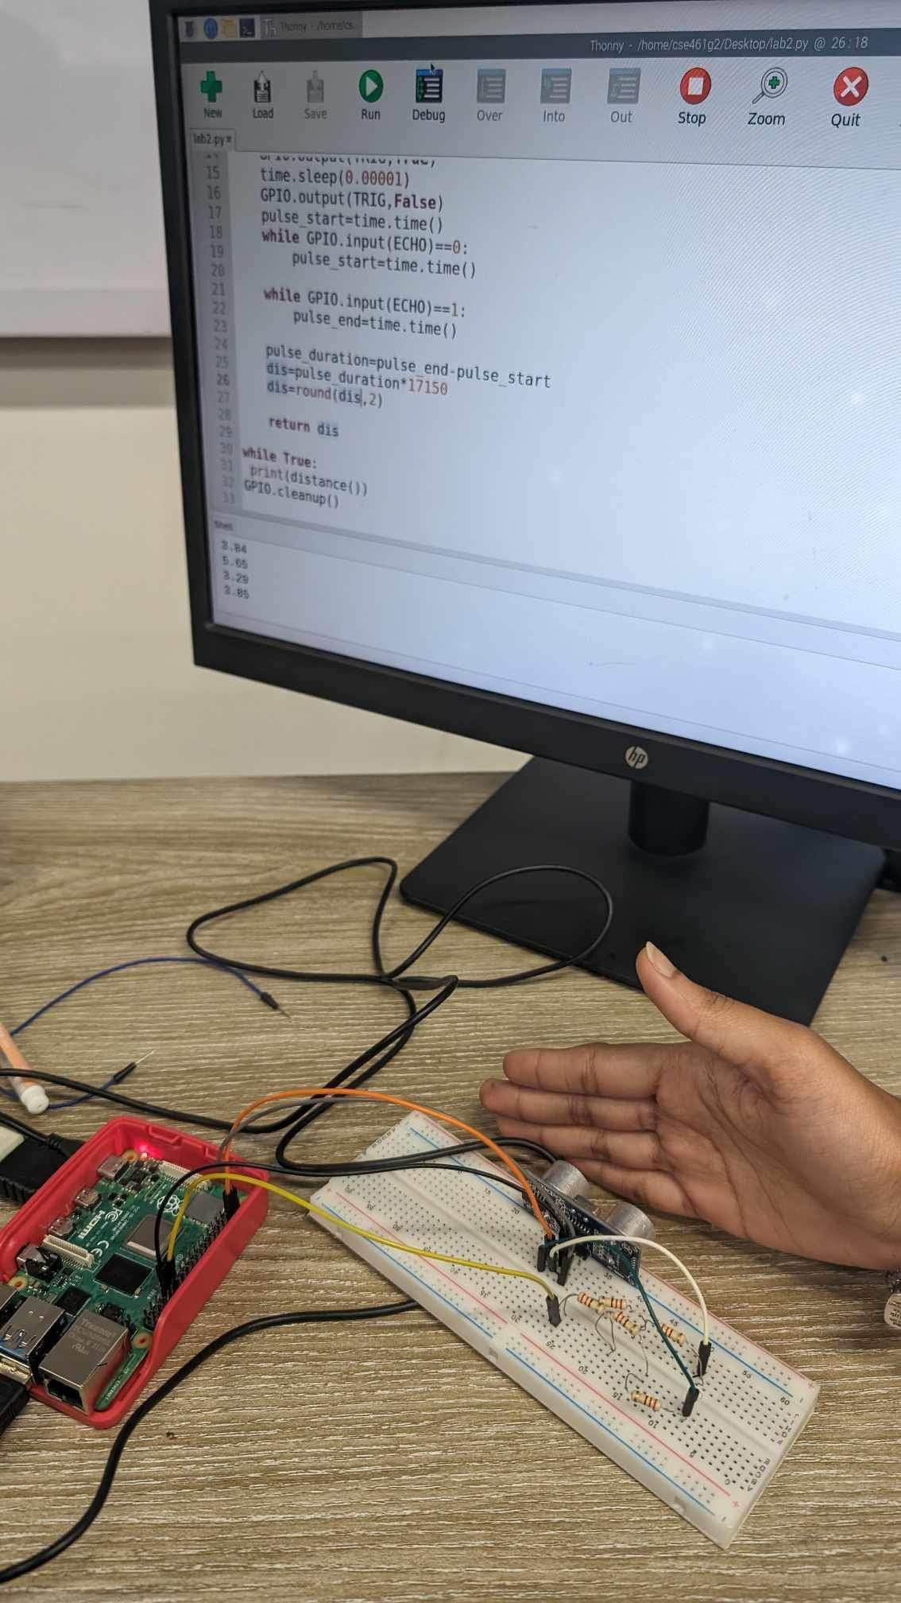

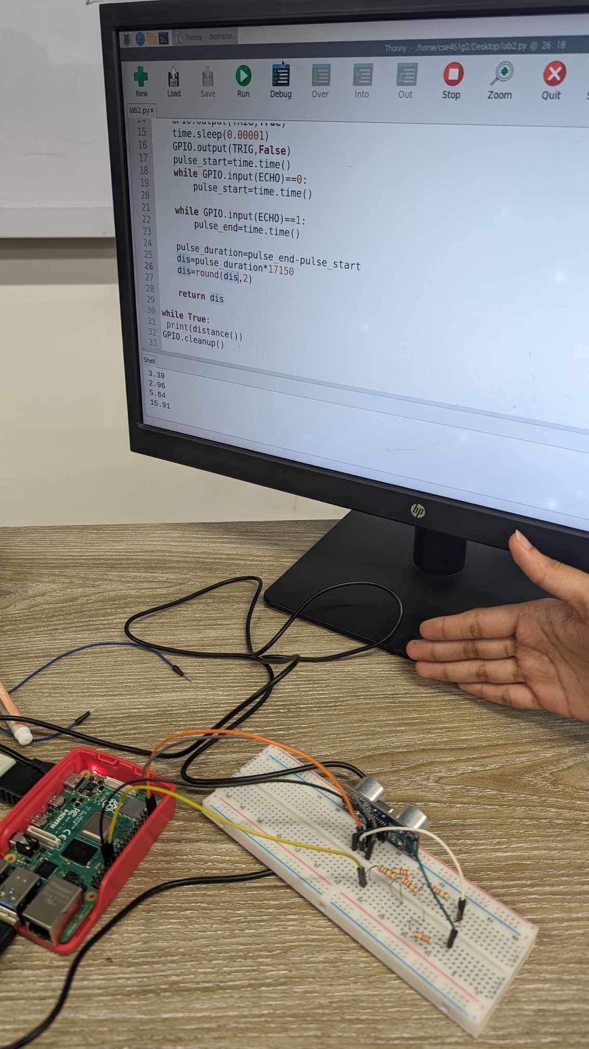

**Lab Task**

**1) Why are the resistors used?**

Resistors play a vital role in safeguarding the Raspberry Pi's well-being and ensuring the proper functioning of the ultrasonic sensor. These resistors serve the purpose of controlling the current flow from the Raspberry Pi's GPIO pin to the trigger pin of the ultrasonic sensor. Its function is to prevent excessive current from reaching the GPIO pin, thus preventing potential damage to it. These also functions as a pull-up resistor for the echo pin of the ultrasonic sensor. Its role is to maintain a consistent voltage level on the echo pin when the sensor is not actively sending or receiving signals. This ensures that the sensor operates reliably, even when not in active use, and provides a known reference voltage level for accurate measurements.